**Transformation of elastic constants**

The elastic property of a cylinder is assumed to be curvilinear orthotropic and the principle direction of the material coincides with the *z* axis of the cylinder (figure 1).



Figure 1: Cylindrical coordinate and Cartesian coordinate systems

The elastic constants in cylindrical coordinate  are



Now let us consider an arbitrary point *P* in the cylinder. Locally, the cylindrical coordinate  at *P* is equivalent to the Cartesian coordinate  (see figure 2). To find the condition for the degeneration from curvilinear orthotropic symmetry in  to transversely isotropic symmetry in , we first need to investigate the transformation of the elastic constants under a rotation of the coordinate system.



Figure 2: Local coordinates and rotation of the system

Let the local coordinate  be rotated with *zl* axis by an angle *φ*. Then the new elastic constants  in new local coordinate system  are



Generally,  and are not zero[1].

However, if the cylinder is transversely isotropic in cylindrical coordinates , namely,

.

Under this condition, we will find that



and



which means that . That’s to say, the elastic constants remain unchanged during the rotation of coordinate system for a transversely isotropic body. Based on this result, we can conclude that if an elastic body is transversely isotropic in , then it is also transversely isotropic in . Note that it is required that the principle directions of the material is along *z* axis such that the above conclusion is justified.









As an example, we try to find the material constants in Jolicoeur’s paper. The compliance matrix of cylinders with 105° and 65° helix angles is shown in the following. The helix angle denotes the angle between the fiber direction and the cross-section of the cylinder.

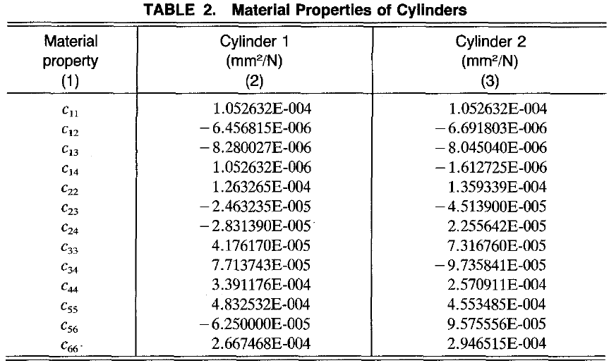

Applying the above transformation relations, the stiffness and compliance matrixes in material coordinates are found to be

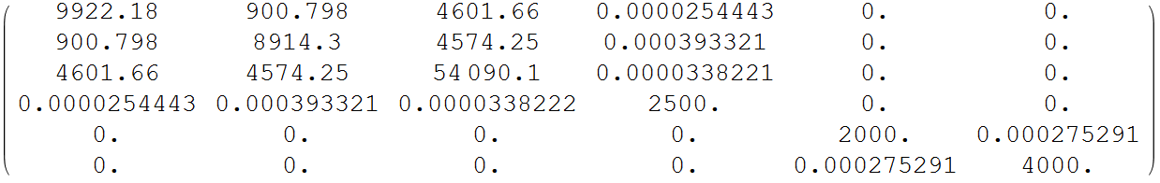

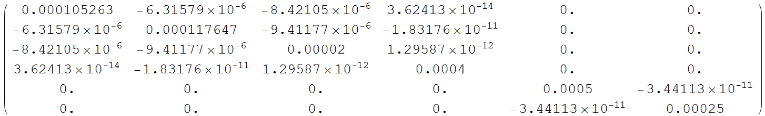

[1] S.G. Lekhnitskii, Theory of elasticity of an anisotropic body, Mir Publishers, 1981.